ECON1020
Singapore Impact Report
COVER SHEET

- Name: Xianglong Lin

- Student number (8 digits): 45791439

- Wordcount: 1372

- Declaration: I, Xianglong Lin, declare that this report is my own work and all the materials from other sources are fully and properly referenced.

1. Revise the Impact Report
(a)
The COVID-19 pandemic significantly impacted Singapore’s economy from 2020 to 2022. As a trade-reliant open economy, Singapore not only faced the pandemic but also needed to navigate global economic turbulence and supply chain disruptions. Figure 1 demonstrates the economic shifts across different phases: pre-pandemic, during the pandemic, and post-pandemic recovery.

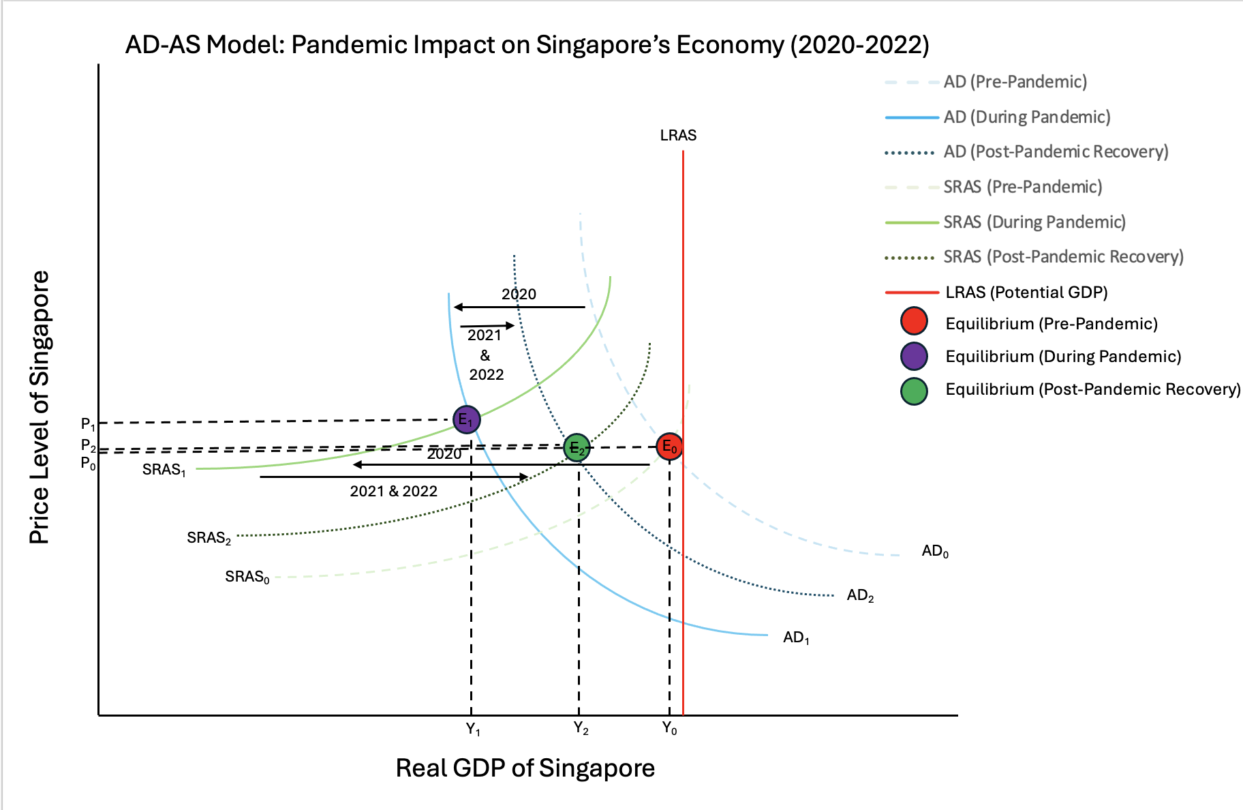

Figure 1. AD-AS Model: Pandemic Impact on Singapore’s Economy (2020-2022)

- Economic Contraction and Recession: During the pandemic, the AD and SRAS curves shifted left, as shown in Figure 1, reflecting the dual effects of declining demand and limited production. Singapore's GDP contracted by 5.4% in 2020, entering a technical recession (Singapore Department of Statistics, 2024). Aviation, hotels and retail were hit hard by the decline in consumer demand, while supply chain disruptions reduced manufacturing production.

- Collapse of Tourism and Transportation Industries: Tourism, an important economic sector, was hit hard as global travel restrictions sharply reduced international tourists by over 85% in 2020 (Singapore Tourism Board, 2024). Hotel and airline revenues plummeted, triggering layoffs and closures, reflected in a significant AD curve shift to the left in Figure 1.

- Rising Unemployment and Job Losses: Shrinking demand in key sectors forced companies to lay off staff or cut wages, leading to a simultaneous drop in GDP and price levels. By 2021, Singapore’s unemployment rate rose to 4.5%, with youth unemployment exceeding 10%, showing the pandemic’s disproportionate impact on young workers.

- Digital Transformation and Green Recovery: The pandemic accelerated digitalisation, with businesses adopting e-commerce and remote work. Sectors such as online shopping and food delivery thrived. In response, the government launched green recovery initiatives, investing in sustainable projects to foster employment and resilience. The gradual rightward recovery of the AD and SRAS curves reflects the economy’s progress, though tourism and aviation remain sluggish.

- Supply Chain Vulnerability and Diversification: The pandemic exposed Singapore’s reliance on single-source supply chains. To boost resilience, the government adopted a diversification strategy, increasing local production in critical sectors like pharmaceuticals. The rightward shift of the SRAS curve highlights productivity gains and supply chain optimisation.

The COVID-19 pandemic prompted Singapore to re-examine its economic development priorities to strengthen its resilience in dealing with future crises. The government's long-term strategic priorities are innovation, research and sustainable development, and leveraging Singapore's strengths in finance, technology and logistics to actively respond to the uncertainties of the post-pandemic era and complete a higher-quality and sustainable economic transformation.

(b)
The MAS implemented a series of monetary policies to cope with the economic impact of the COVID-19 pandemic, aiming to maintain financial stability, ensure credit supply, and promote economic recovery. Figure 2 reflects the changes in unemployment rate and the effects of policies.

(World Bank Group, 2024)
Figure 2. Singapore’s Total Unemployment Rate (2020–2022)
MAS reduced policy interest rates to lower borrowing costs and encourage consumption and investment (Monetary Authority of Singapore, 2024). However, the unemployment rate still reached a peak of 4.6% in 2021, highlighting the severe recession of the economy. The continued support of monetary policy reduced the unemployment rate to 3.6% in 2022, marking the economic recovery of Singapore, according to the Singapore Department of Statistics (2024).

In addition, MAS regulated the exchange rate to prevent excessive appreciation of the Singapore dollar (SGD) to protect the competitiveness of the export industry (Ong, n.d.). The SGD liquidity facility launched by MAS provided additional funds to the banking system to ensure that small and medium-sized enterprises can obtain loan support.

MAS also stabilised market expectations through forward-looking guidance and maintained a loose policy (Monetary Authority of Singapore, 2024). MAS also coordinated with government fiscal plans such as the wage support program JSS to subsidise corporate wages to stabilise employment (Singapore Government, 2024).

During the pandemic, MAS actively monitored and intervened in the market as necessary to prevent market disruptions. Additionally, it introduced green finance into its monetary policy framework to encourage investments aligned with the Sustainable Development Goals.

These measures stabilised the financial system and supported the recovery and development of enterprises. MAS used monetary easing, exchange rate management, and close coordination of fiscal policies to help Singapore successfully weather the impact of the pandemic.

(c)
The Singapore government implemented various fiscal policies from 2020 to 2022 to mitigate the impact of the pandemic on the economy, aiming to provide financial support, protect employment, stimulate economic activity, and help businesses and individuals address challenges. Figure 3 shows the changes in the youth unemployment rate and the effectiveness of policies in the youth labor market.

(World Bank Group, 2024)

Figure 3. Youth Unemployment Rate in Singapore (Ages 15–24) (2020–2022)

- Recovery Budget and Support Plan: Various recovery budgets and support plans were implemented by the government to provide immediate assistance to individuals and businesses affected by the pandemic. The needs of the medical and vulnerable sectors were prioritised, and businesses were assisted through the economic downturn. (Singapore Government, 2024)

- Job Support Scheme (JSS): JSS provided wage subsidies to businesses, allowing them to retain employees when revenues decreased. This policy effectively mitigated the rising trend of unemployment, especially the youth unemployment rate, which reached a peak of 10% in 2020 and then dropped to 8% in 2022 as the economy recovered, as shown in Figure 3.

- Enhanced Wage Subsidy Plan: The government implemented an enhanced wage subsidy plan to share employee salary costs with enterprises, incentivising them to hire and retain local employees and alleviate wage pressure during recovery.

- Key Industry Support: The government provided targeted support to industries such as aviation, tourism, and hospitality that were severely affected by the pandemic, ensuring that they could operate despite travel restrictions and reduced demand.

- Tax Deferral: Enterprises facing cash flow difficulties benefited from the tax deferral policy, which alleviated short-term financial pressure and enhance the flexibility of management operations and cash flow during uncertain periods.

- Medical Expenditure and Vaccine Procurement: Singapore significantly increased medical expenditure for detection and treatment. The government also invested substantial funds in purchasing and distributing vaccines to lay the foundation for the full economic restart with high vaccination rates (Ministry of Health Singapore, 2024).

- Digital Transformation Investment: The government promoted the accelerated digital transformation to help enterprises adapt to remote work and new consumption habits. This not only improved the adaptability of enterprises, but also created new growth points in the digital economy.

- Support for Low-Income Families: The government expanded social support programs to provide additional financial support for low-income families, so that vulnerable groups could receive basic resources and assistance during the most severe impact of the pandemic.

Singapore's fiscal policy played an important role in protecting employment, supporting key industries and promoting economic recovery. The wage support program effectively reduced the youth unemployment rate, which dropped from 10% in 2020 to 8% in 2022, as shown in Figure 3. Meanwhile, investments in healthcare and digital transformation further enhanced the resilience of the economy, paving the way for sustainable growth.

2. Reflection
- ChatGPT’s report has captured the structure and core themes of the task, accurately pointing out key economic impacts such as a decline in GDP, an increase in unemployment, and the fiscal and monetary policy responses taken by the government. AI clearly outlined policies such as JSS and quantitative easing, which had played an important role in Singapore's response to COVID-19. The report is well-structured, logically coherent, and the information is presented in an orderly manner.

- The report of ChatGPT lacks in-depth analysis and data support. For example, detailed data on youth and overall unemployment rates are not listed, nor authoritative official sources cited. In addition, the report fails to effectively link the charts with policies, thus failing to fully demonstrate the causal relationship between government intervention and economic outcomes. The discussion on sustainable development remains superficial, and there is no in-depth exploration of how green finance can be consistent with Singapore's long-term economic goals.

- To stay competitive in the AI-powered world, I will focus on critical thinking, complex data analysis, and professional economics knowledge – skills that AI struggles to possess. Furthermore, I will strengthen my ability to interpret policies, communicate with stakeholders, and make detailed judgments. These practical skills will enable me to provide insights beyond automated reports. Meanwhile, I will also constantly improve my skills with AI tools. Furthermore, establishing a network in the field of economics and engaging in interdisciplinary research will ensure that I maintain value and differentiation in an increasingly automated era of big data.

3. References
Ministry of Health Singapore. (2024, March 28). Healthier SG: Towards better health and quality of life.
Government of Singapore. https://www.healthiersg.gov.sg
Monetary Authority of Singapore. (2024, October 14). Monetary Authority of Singapore (MAS). Government
of Singapore. https://www.mas.gov.sg
Ong, C. T. (n.d.). An exchange-rate-centred monetary policy system: Singapore’s experience. BIS Papers No.
73, 307–315. Bank for International Settlements. https://www.bis.org
Singapore Department of Statistics. (2024, October 14). Singapore Department of Statistics (DOS).
Government of Singapore. https://www.singstat.gov.sg
Singapore Government. (2024, March 27). Budget 2024. Ministry of Finance, Singapore.
https://www.mof.gov.sg/singaporebudget
Singapore Tourism Board. (2024, October 9). Singapore Tourism Board (STB). Government of Singapore.
https://www.stb.gov.sg
World Bank Group. (2024). DataBank: World development indicators. The World Bank.
https://databank.worldbank.org/source/world-development-indicators

